Community Art School Sign Up Form
If you would like to attend our new Community Art School for artists with Learning Disabilities in Newham, please complete this form and email it to artschool@hopefulfutures.net
About Me
Full name:  Preferred name: | D.O.B (age):  Ethnicity:
Address:

Phone Number:

Email:

Name of who we should contact in an emergency:

Their relationship to you:

Phone number:

Address:
My Communication
How I communicate:

How you should communicate with me:

My Health and Support Needs
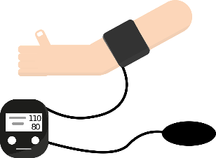
My diagnoses:
Please include all physical and mental health needs, sensory impairment, mobility needs, as well as autism/learning disability etc. Please tell us what support you need, for example ‘I have epilepsy, I have an epilepsy care plan which says when emergency services should be called, which you will need to be aware of’.

Any Allergies?

I need support with personal care e.g going to the toilet and/or eating & drinking? (Yes or No with details of support needed)

I sometimes need 1:1 support? (Yes or No and please detail why)

About My Art
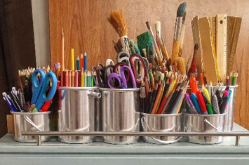
My favourite way to do art is:

My favourite piece of art that I’ve made was:

Art that I’d like to try is:

Please tick which day & terms you’d Like to sign up for (you can attend on a Wednesday OR Saturday but can come to as many terms as you like. Please see ‘Art School Important Information’ for term dates)
Wednesdays (2pm – 5pm)  ☐ |  | Saturdays (10am – 1pm)  ☐
Term 1 ☐  Term 2 ☐  Term 3 ☐  Term 4 ☐  Term 5 ☐  Term 6 ☐  Term 7 ☐ |  | Term 1 ☐  Term 2 ☐  Term 3 ☐  Term 4 ☐  Term 5 ☐  Term 6 ☐  Term 7 ☐
Payment
(Please tick how you’d like to pay. We charge £5 per session (£30 per term) to cover the cost of art materials. Payment is due before each term starts so can be paid in stages through the year. We can offer a reduced cost if you do not get welfare benefits, if this is you please tell us)
Bank Transfer ☐
Cash ☐
Cheque ☐

We will provide you with a receipt of your payment.

By completing this form, you give Hopeful Futures consent to process your data. You can request our GDPR privacy policy by emailing hello@hopefulfutures.net

